For Immediate Release February 1, 2023
Contact: Ann Bennett 301-725-7975, Director@laurelhistoricalsociety.org

It’s All Laurel: City Limits and Beyond Opens At Laurel Museum
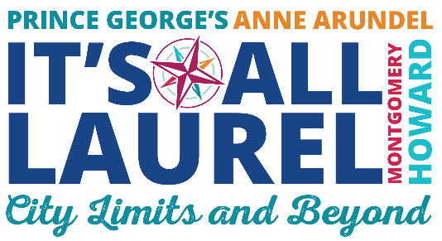
Laurel, MD Where – and What -- is Laurel? Those are the questions “It’s All Laurel: City Limits and Beyond” works to answer at a new exhibit opening February 18 at the Laurel Museum. Though located in the City of Laurel, the exhibit strives to demonstrate that “Laurel” is more than areas within the city limits. Focusing on communities ranging from Scaggsville to Russett to the historic African American community of Bacontown, the exhibit reveals the breadth of Laurel – geographically, demographically and historically. The exhibit reminds visitors that in addition to the City of Laurel and Prince George’s County, Laurel extends into Howard, Anne Arundel and even Montgomery Counties –north, south, east, and west. Within each county are communities with distinctive personalities and surprising details that in one way or another are all part of Laurel.
“With this exhibit we’re trying to show that Laurel is many things – and many places, “stated LHS Executive Director Ann Bennett. “We made a special effort to work with “Community Curators” - current and past residents of each area- to discover their community’s traditions, special events and culture. We’ve combined that with demographic, geographic, and historic information from our collections to offer a snapshot of some of the many neighborhoods and communities that make up Laurel.”
Visitors will discover a 1790s log cabin in Montgomery County, and Maryland’s largest naturally occurring freshwater lake in Russett. They will follow dinosaur’s footsteps in South Laurel, racehorses in Howard County (North Laurel), crab fests (Maryland City), the Lincoln funeral florist (Oak Crest) and a 120 year-old celebration (The Grove). Along the way they will meet people who are committed to their churches, neighbors, and communities. People like Maggie Hubbard, who noted: “One of my best memories is going to Edmonston Elementary School because we walked on a path through the woods.” (Fairlawn/Laurel Hills)
The exhibit also explores how the City of Laurel itself has grown – from a factory and farm, to a 1950 annexation to today’s more recent expansion into Konterra. Inside the City limits there are also neighborhoods with a special look and feel, ranging from Old Town to the historic Grove community to upscale Wellington, early suburb Fairlawn/Laurel Hills and Arbory. The city’s growth is a reminder that as the city grew – so did the communities and neighborhoods in surrounding counties.
“It's All Laurel: City Limits and Beyond” will run through August 2024. The Laurel Museum is located in the City of Laurel at 817 Main Street, Laurel Maryland 20707. Hours are 12-4pm Friday-Sunday. Group Tours and Research Mon-Fri. by appointment only. Admission is free. For more information visit www.laurelhistoricalsociety.org or contact us at info@laurelhistoricalsociety.org, 301-725-7975.
##

